

November 2009 Newsletter

Next SCHPS meeting, November 12th 6:30pm

116 East 6th Street
&
224 East 6th Street

President
Judy Belfer, 324.7779

Vice President
Janet Corcoran, 386.3428

Secretary
Rex Grove, 335.8727

Treasurer
Frenc Beiwel, 386.1969

Executive Director
Karen Anderson, 324.0257

Newsletter Editors
David Pai, 579.1996

Board Members
Mary Costello
Duane Timm, 323.4077
Fred Vogt, 570.0886

East 6th Street Mansion Tour
November 12th at 6:30 P.M.
Kimball-Stevenson Mansion, 116 E. 6th St. & Dr. E.S. Barrows Mansion, 224 E. 6th St.

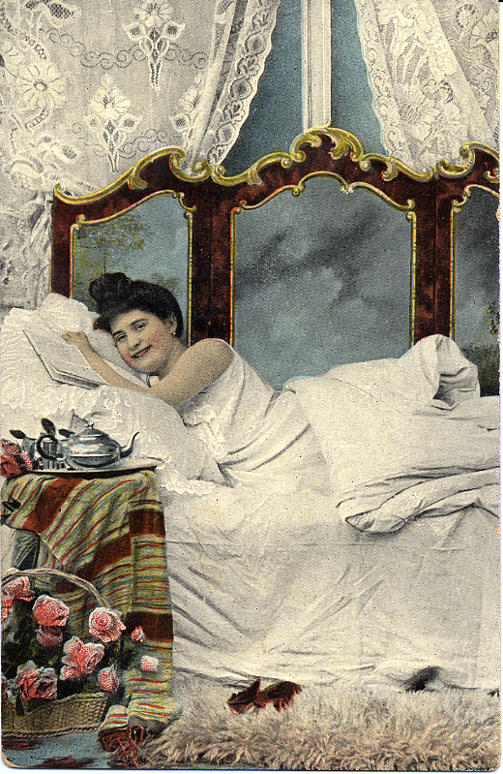
Davenport has always been a naughty town! Major Gordon, the town surveyor, was so inebriated when he platted the first city streets that they took a decided veer--four feet off to the north. Even before the ink could dry on the fledgling town’s incorporation papers, Captain John Linch had already taken it upon himself to erect the city’s first and most essential public building—a 22 x 16 ft. log saloon on the corner of Front and Ripley Street. There, he sold liquor (without a license) with such abandon that the city’s center soon became better known as “Brimstone Corner”.

Flotillas of floating log raft whore houses sprung up in the bulrushes at the foot of Marquette Street. Angry crowds of vigilantes marched to the riverbank nightly with guns, dogs and torches---but with no success. The proprietors of the floating bawdy houses just chopped the ropes and floated out to the state line in the middle of the river and continued, “business” as usual.
Won’t you join us?

By 1894, Scott County was home to well over 240 saloons---150 of them located within the city limits of shameful Davenport. Rev. William Lloyd Clark made a life’s work out crusading through the 42 “Bucktown” brothels and saloons clustered in two city blocks at the foot of the Government Bridge. By 1906, Rev. Cosgrove had to publicly declare from the pulpit that Davenport was truly “The Wickedest City In America.” Good old SIN and Davenport just seemed to have a proclivity for one another—which lasted from one century to the next!

Kimball-Stevenson Mansion & Bordello-116 E. 6th Street, C. 1871-1873
(Second building east of Brady St.)

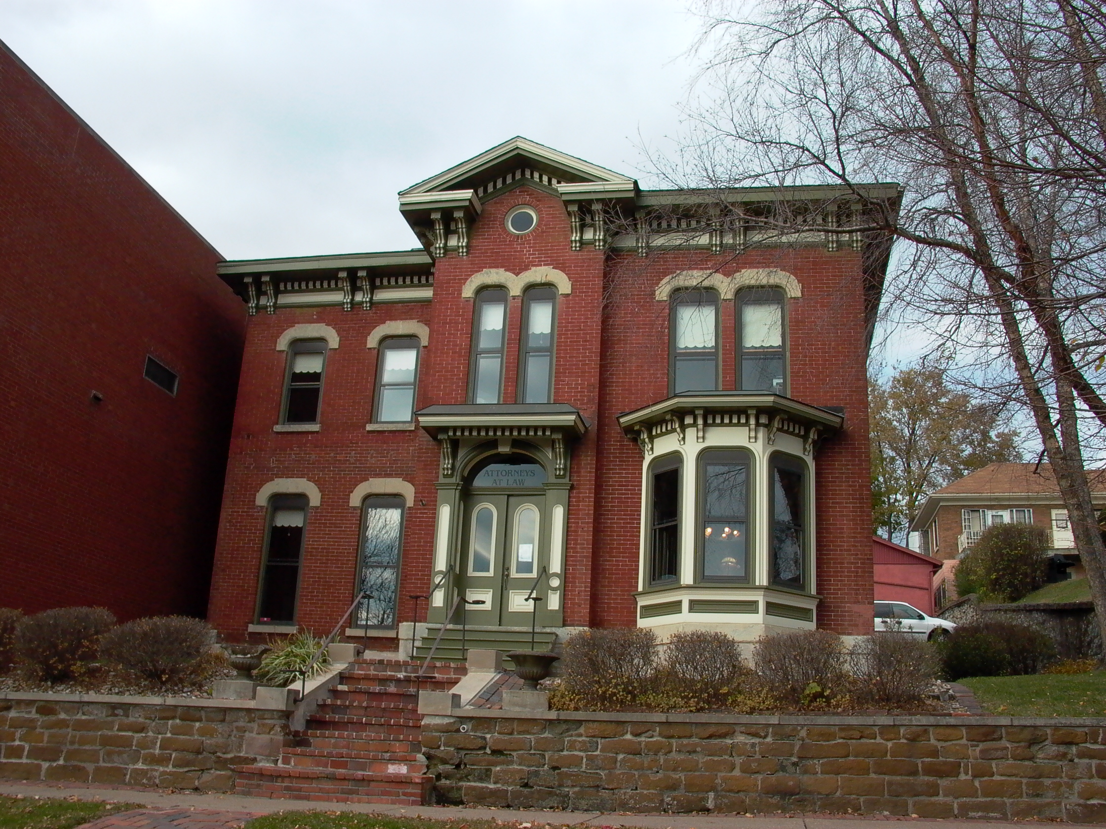
During the Great Depression (and construction of the nearby lock and dam system!), the Kimball-Stevenson Mansion helped celebrate Davenport’s long tradition of SIN by becoming one of its most notorious nickel “Needle-beer” brothels. (Beer injected with 180 proof alcohol--through the cork.) Gentlemen could sit in the elegantly appointed parlor while gazing into the strategically placed hall mirror---which perfectly reflected the “ladies of the evening,” as they posed and preened upon the hall stairs.

Today, this beautiful 1871-1873 Italianate mansion is owned by Barbara Maness.
Barbara has graciously invited SCHPS members to tour her beautifully restored law offices, which feature faux grained woodwork and faux marbled fireplaces—and hall mirror. (Try YOUR luck!) This grand home was once the residence of Chicago & Pacific Railroad Superintendent J.J. Kimball, for whom Davenport’s famous Kimball House railroading hotel was named.

Egbert Storrs Barrows Mansion-224 E. 6th Street, C. 1850-1853
( NW C of 6th & Pershing St.)

Two blocks east of the Kimball-Stevenson House, at the corner of 6th & Pershing Street, we will visit our second tour house of the evening---the former residence of Dr. Egbert Storrs Barrows. Barrows was the first doctor to arrive in frontier Scott County and only the second doctor to ever practice in Wisconsin Territory. Dr. Barrows liked to brag that he was the only physician practicing in a 100 mile beltway above St. Louis, stretching from the Mississippi River to the Pacific Ocean.

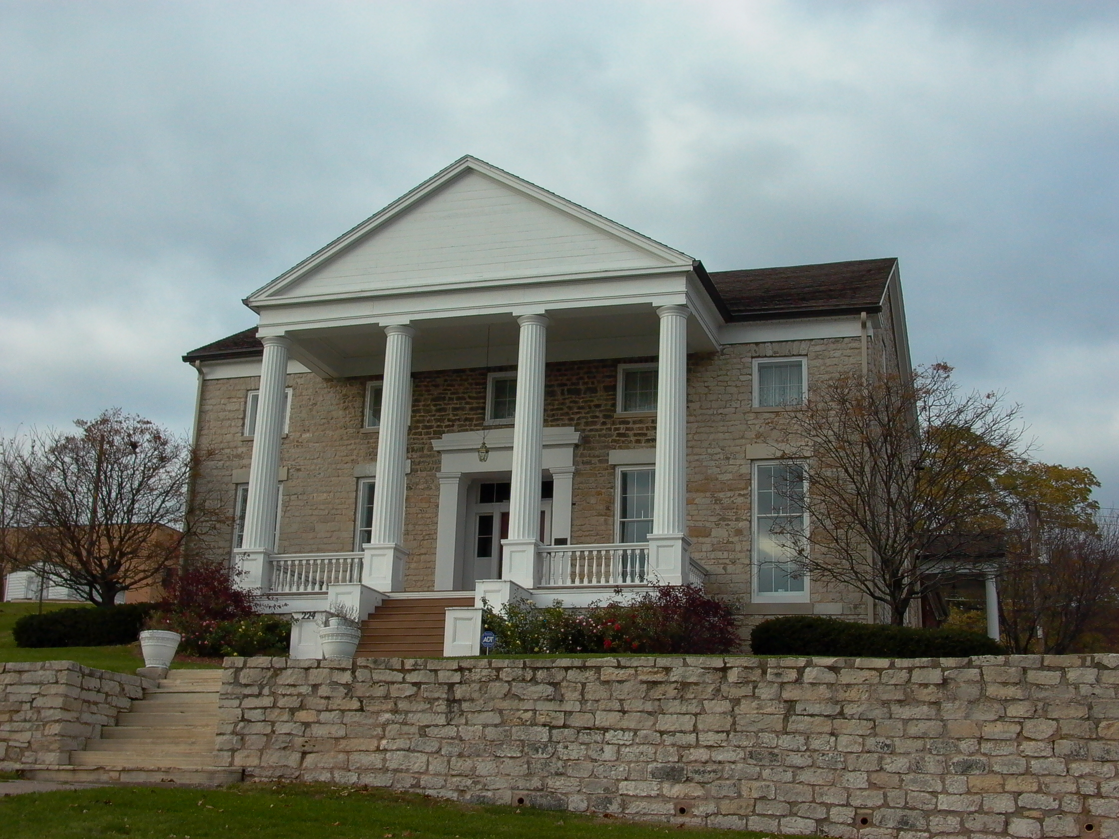
Dr. Barrows was an honored military doctor and veteran of the Seminole Wars prior to arriving in frontier Davenport. Legendary stories soon began circulating among early settlers about his eccentric bed-side manner once he entered private practice. Once, after coming upon a threshing machine accident, Dr. Barrows assessed the situation, called for a common hand saw, and then promptly sawed the injured man’s arm off.

After retirement, Dr. Barrows warned his friends “not to take medicine, and never trust doctors.” To emphasize his point, he presented an adze to the Davenport Academy of Sciences for public display which warned, “John Blank, who removed from Pennsylvania to Iowa in 1832, took Dr. Barrow’s medicine and died. He left the adze”.

Today, Dr. Barrow’s classic Greek Revival stone mansion, with its signature two story columned portico where Dr. Barrows liked to rock in his chair while watching steamboats struggle over the Rock Island Rapids, is the new home of David Leo and Andrew Patterson. They have graciously invited SCHPS members to tour this fascinating relic of early Davenport’s frontier history, which has defined E. 6th Street’s rich architectural history for over 155 years.

Since SCHPS will be touring a private home and business, this will be
a paid “member’s only” tour.

Hats off to Duane Timm!!!!
SCHPS Board Member Duane Timm operates one of the nations most historic and authentic hand blocked wall paper companies in the nation--Bassett & Vollum, Davenport, Iowa. Duane recently donated two rooms of period wall paper to the German American Heritage Center to help complete their restoration of two former hotel rooms just in time for opening of “The Immigrant Experience” exhibit. (The Center was once the historic Germania House Hotel.) Tim is to be commended for his generosity--and the endless volunteer hours he devotes to furthering the preservation efforts of his Gold Coast & Hamburg neighborhood, as well as SCHPS. Take a bow Duane Timm!!

Need Xmas Stocking Stuffers???-
Give a personalized gift, at bargain price (100% donation to the LeClaire House restoration)
10 Davenport Historic Building Note Cards- $10.00 (By artist Ward Olson)
LeClaire House History/Coloring Books- $6.00
Crystal Paper Weights, etched with image of City Hall- $3.00 To order, call---Karen Anderson
Riverboat watercolor prints- $20.00 (By artist Ward Olson) 563.324.0257
LeClaire House watercolor print- $20.00 (By artist Ward Olson)
J.S Steamboat tote bags- $10.00 (By artist Ward Olson)
War Eagle Steamboat/Trinity Cathedral Post Cards- $.50
SCHPS Membership- $15.00 e-mail newsletter or $20.00 mailed
Join SCHPS Today-
--10 Newsletters & calendars of upcoming events each year
--SCHPS private house tours and one-of-a-kind special events
--Share your interest in historic preservation
--$15.00 per year for e-mailed newsletter
--$20.00 per year for mailed copy
Send to-SCHPS
P.O. Box 5017
Bettendorf, Iowa 52722

Congratulations to GAHC Members!
Over 4,000 visitors attended the Oct. 3-4th grand opening
of the German American Heritage Center’s
“The Immigrant Experience” exhibit, while 98 new members
joined the organization and 40 renewed.
Take a bow GAHC volunteers!

Calendar Of Events~
Nov 8, 2 pm. German American Heritage Center (GAHC) program on the Davenport Shooting Club and the Old and New Schuetzenpark. Founded in 1864, the Davenport Shooting Club is one of the oldest single shot rifle clubs in the German tradition.
Nov 10, The Arsenal Club, Black Hawk College will sponsor a luncheon seminar “The Quad-Cities in WWII”. Lunch at 11:30am; program at 12:15pm.
Nov 19, Christmas Village Exhibit, will open at the GAHC Nov 20. The village and Nativity scenes include figures hand carved in the 1700s and 1800s, and collected in Christmas markets, antique shops and flea markets in Slovenia, Austria and Germany.
Nov 19, Joyeux Noel at the Bettendorf Public Library. This 2005 film commemorates the 95th anniversary of three armies’ “Christmas Eve Truce” in World War I. On that one day soldiers from the trenches engaged each other in games of soccer and other friendly activities.
Dec. 4 & 5th, 6:00-8:00 P.M.- Christmas in the Villag,e Santa, Living windows, strolling carolers, horse drawn wagon rides and Fireworks Dec. 5^{tt}.

Dec.4 & 6, Christmas In LeClaire, Iowa- Carriage rides, craft fair, living nativity, breakfast with Santa at Happy Joe’s
Dec 6, Annual Zither and Bell Choir Concert at the GAHC. The GAHC is the home of the Davenport Zither Ensemble(DZE). It has become the largest community based zither ensemble in the United States, and the only zither ensemble which is continuing to grow.
Dec. 10th, 6:30 P.M.- SCHPS Christmas Dinner & Tour, German Amer. Heritage Center

